**Data warehouse Components**

We will learn about the Data warehouse Components and Architecture of Data Warehouse with Diagram as shown below:

[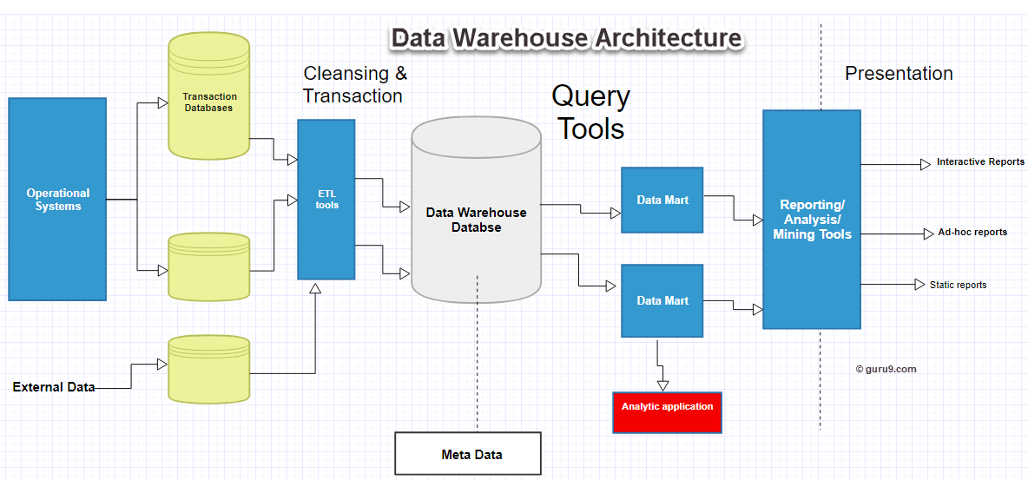](https://www.guru99.com/images/1/022218_0735_DataWarehou2.png)Data Warehouse Architecture

The Data Warehouse is based on an RDBMS server which is a central information repository that is surrounded by some key Data Warehousing components to make the entire environment functional, manageable and accessible.

There are mainly five Data Warehouse Components:

**Data Warehouse Database**

The central database is the foundation of the data warehousing environment. This database is implemented on the RDBMS technology. Although, this kind of implementation is constrained by the fact that traditional RDBMS system is optimized for transactional database processing and not for data warehousing. For instance, ad-hoc query, multi-table joins, aggregates are resource intensive and slow down performance.

Hence, alternative approaches to Database are used as listed below-

* In a data warehouse, relational databases are deployed in parallel to allow for scalability. Parallel relational databases also allow shared memory or shared nothing model on various multiprocessor configurations or massively parallel processors.
* New index structures are used to bypass relational table scan and improve speed.
* Use of multidimensional database (MDDBs) to overcome any limitations which are placed because of the relational Data Warehouse Models. Example: Essbase from Oracle.

**Sourcing, Acquisition, Clean-up and Transformation Tools (ETL)**

The data sourcing, transformation, and migration tools are used for performing all the conversions, summarizations, and all the changes needed to transform data into a unified format in the data warehouse. They are also called Extract, Transform and Load (ETL) Tools.

Their functionality includes:

* Anonymize data as per regulatory stipulations.
* Eliminating unwanted data in operational databases from loading into Data warehouse.
* Search and replace common names and definitions for data arriving from different sources.
* Calculating summaries and derived data
* In case of missing data, populate them with defaults.
* De-duplicated repeated data arriving from multiple data sources.

These Extract, Transform, and Load tools may generate cron jobs, background jobs, Cobol programs, shell scripts, etc. that regularly update data in data warehouse. These tools are also helpful to maintain the Metadata.

These ETL Tools have to deal with challenges of Database & Data heterogeneity.

**Metadata**

The name Meta Data suggests some high-level technological Data Warehousing Concepts. However, it is quite simple. Metadata is data about data which defines the data warehouse. It is used for building, maintaining and managing the data warehouse.

In the Data Warehouse Architecture, meta-data plays an important role as it specifies the source, usage, values, and features of data warehouse data. It also defines how data can be changed and processed. It is closely connected to the data warehouse.

For example, a line in sales database may contain:

4030 KJ732 299.90

This is a meaningless data until we consult the Meta that tell us it was

* Model number: 4030
* Sales Agent ID: KJ732
* Total sales amount of $299.90

Therefore, Meta Data are essential ingredients in the transformation of data into knowledge.

Metadata helps to answer the following questions

* What tables, attributes, and keys does the Data Warehouse contain?
* Where did the data come from?
* How many times do data get reloaded?
* What transformations were applied with cleansing?

Metadata can be classified into following categories:

1. **Technical Meta Data**: This kind of Metadata contains information about warehouse which is used by Data warehouse designers and administrators.
2. **Business Meta Data:** This kind of Metadata contains detail that gives end-users a way easy to understand information stored in the data warehouse.

## Query Tools

One of the primary objects of data warehousing is to provide information to businesses to make strategic decisions. Query tools allow users to interact with the data warehouse system.

These tools fall into four different categories:

1. Query and reporting tools
2. Application Development tools
3. Data mining tools
4. OLAP tools

#### 1. Query and reporting tools:

Query and reporting tools can be further divided into

* Reporting tools
* Managed query tools

**Reporting tools:**

Reporting tools can be further divided into production reporting tools and desktop report writer.

1. Report writers: This kind of reporting tool are tools designed for end-users for their analysis.
2. Production reporting: This kind of tools allows organizations to generate regular operational reports. It also supports high volume batch jobs like printing and calculating. Some popular reporting tools are Brio, Business Objects, Oracle, PowerSoft, SAS Institute.

**Managed query tools:**

This kind of access tools helps end users to resolve snags in database and SQL and database structure by inserting meta-layer between users and database.

#### 2. Application development tools:

Sometimes built-in graphical and analytical tools do not satisfy the analytical needs of an organization. In such cases, custom reports are developed using Application development tools.

#### 3. Data mining tools:

Data mining is a process of discovering meaningful new correlation, pattens, and trends by mining large amount data. Data mining tools are used to make this process automatic.

#### 4. OLAP tools:

These tools are based on concepts of a multidimensional database. It allows users to analyse the data using elaborate and complex multidimensional views.

## Data warehouse Bus Architecture

Data warehouse Bus determines the flow of data in your warehouse. The data flow in a data warehouse can be categorized as Inflow, Upflow, Downflow, Outflow and Meta flow.

While designing a Data Bus, one needs to consider the shared dimensions, facts across data marts.

### Data Marts

A data mart is an access layer which is used to get data out to the users. It is presented as an option for large size data warehouse as it takes less time and money to build. However, there is no standard definition of a data mart is differing from person to person.

In a simple word Data mart is a subsidiary of a data warehouse. The data mart is used for partition of data which is created for the specific group of users.

Data marts could be created in the same database as the Data warehouse or a physically separate Database.